1. Source Code

* Controller 🡪 latihan1.php
* Controller 🡪 latihan2.php
* Models 🡪 model1.php
* Views 🡪 view-latihan2.php

1. URL :

* <http://localhost:8888/ci_hadi/index.php/latihan1/penjumlahan/5/10>
* http://localhost:8888/ci_hadi/index.php/latihan2/penjumlahan/5/10

1. 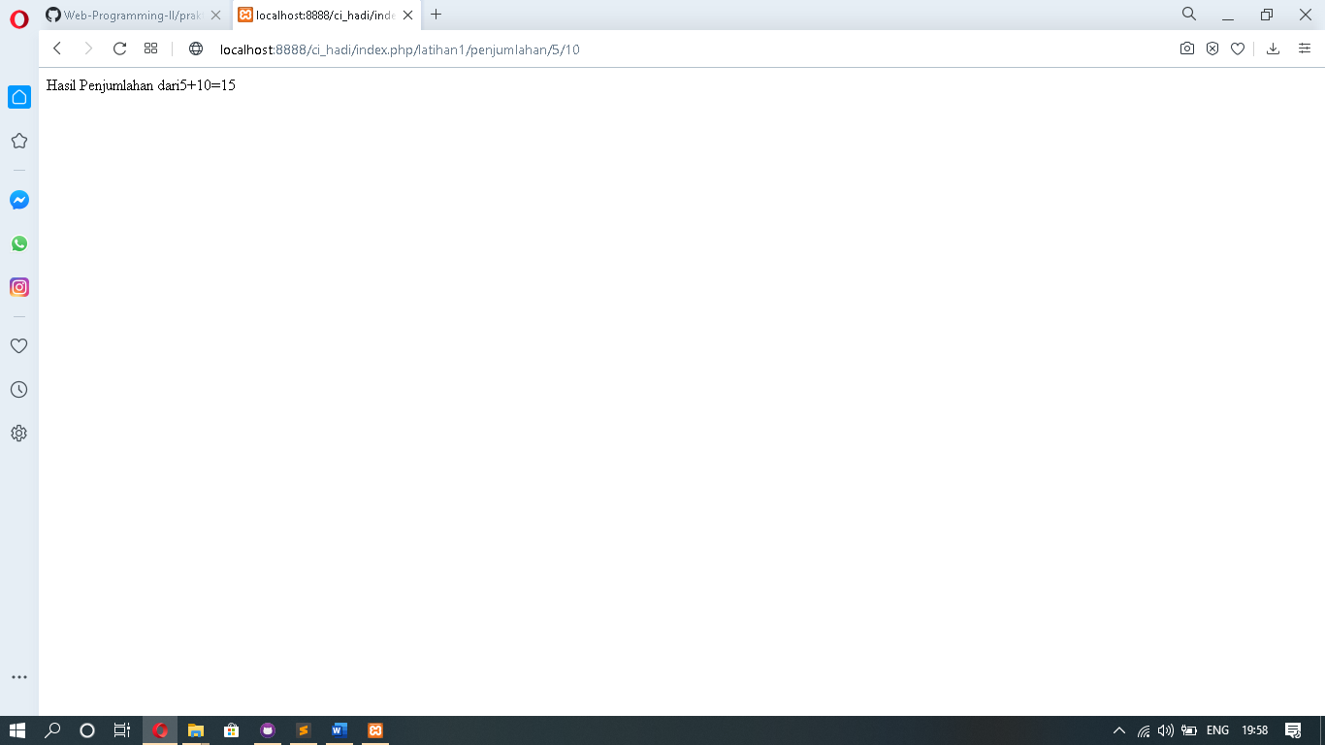Screen Shoot

